Exercise 6

- Order all employees on the basic of the salary they draw.
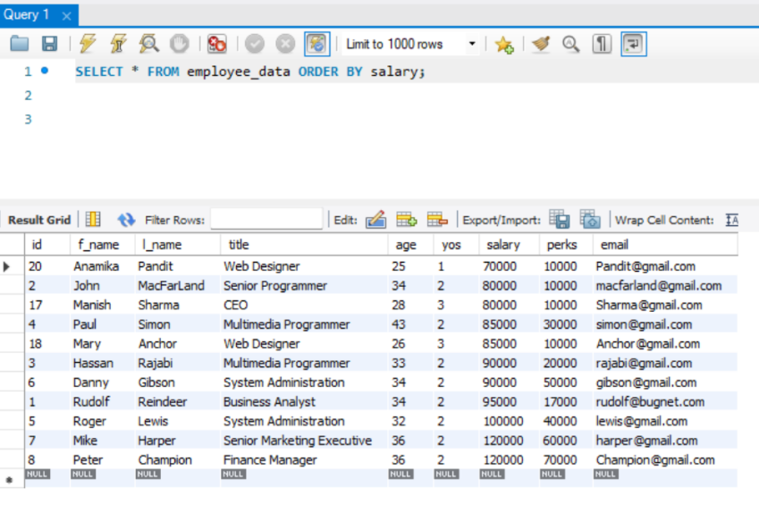
- List all employees in descending order of their years of service.
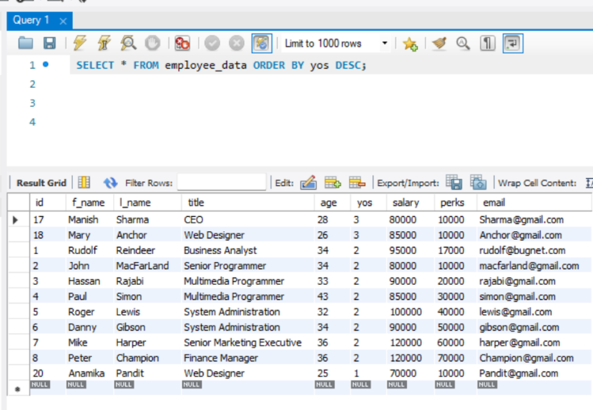
- What does the following statement display?
SELECT emp_id, l_name, title, age from employee_data ORDER By title DESC, age ASC;

Returns id, last name, title and age of all the employees sorted by its title in descending order and age in ascending order
- Display employees(last names followed by first names) who hold the title of either “Programmer” or “web Designer” and sort their last names alphabetically.
